

**Project Initialization and Planning Phase**

|  |  |
| --- | --- |
| Date | 15 July 2024 |
| Team ID | 740684 |
| Project Name | SpaceX Falcon 9 First Stage Landing  Success Predictor |
| Maximum Marks | 3 Marks |

**Define Problem Statements (SpaceX Falcon 9 First Stage Landing Success Predictor):**

Develop a predictive model to determine the likelihood of a successful landing of the Falcon 9 first stage booster. The model should utilize historical launch data, including factors such as launch conditions, rocket specifications, and landing parameters. Accuracy and reliability of the predictions are critical to support mission planning and risk assessment. The ultimate goal is to enhance the efficiency and safety of SpaceX’s reusable rocket program. Analyzing and understanding key variables that impact landing success is essential.

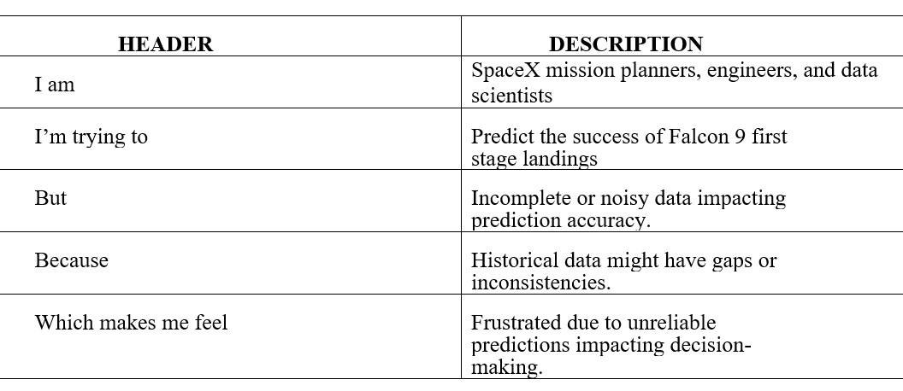

**Example:**





|  |  |  |  |  |  |
| --- | --- | --- | --- | --- | --- |
| **Problem**  **Statement**  **(PS)** | **I am (Customer)** | **I’m trying**  **to** | **But** | **Because** | **Which makes me feel** |
| PS-1 | SpaceX engineers and analysts | Predict the success of Falcon 9 first stage landings | But | Current prediction methods lack accuracy and realtime capabilities | Because precise landing predictions ensure mission success and cost savings |
| PS-2 | Aerospace researchers and stakeholders | Understand the factors influencing Falcon 9 first stage landing outcomes | But | Data analysis is complex due to diverse variables and limited historical data | Because insights into landing performance enhance future mission planning and safety |